**Department of Electrical Engineering and   
Computer Science**

**Faculty Member:** Dr. Shakeel Alvi **Dated:** 10/02/2022

**Semester:** 4th **Section:** BEE 12C

**EE-215:** **Electronic Devices And Circuits**

Lab 2: Introduction to Digital Oscilloscope, Function Generator Operation

**Group Members**

|  |  |  |  |  |
| --- | --- | --- | --- | --- |
| **PLO4/CLO4** | | **PLO5/CLO5** | **PLO8/CLO6** | **PLO9/CLO7** |
| **Name** | **Reg. No** | **Viva /Quiz / Lab Performance**  **5 marks** | **Analysis of Data in Lab Report**  **5 marks** | **Modern Tool Usage**  **5 marks** | **Ethics and Safety**  **5 marks** | **Individual and Team Work**  **5 marks** |
| **Tariq Umar** | **334943** |  |  |  |  |  |
| **Saad Bakhtiar** | **341150** |  |  |  |  |  |
|  |  |  |  |  |  |  |
|  |  |  |  |  |  |  |
|  |  |  |  |  |  |  |

# Laboratory Experiment # 2

## Objectives

To familiarize students with AC voltage source generator and the working of oscilloscope. We also explore the effects of changing the horizontal and vertical sensitivty on the Frequency and Voltage. Dual channels are also utilized on the digital oscilloscope to find the voltage across multiple points within a closed circuit.

## Equipment

The following will be required in this lab experiment:

* Digital Oscilloscope
* Digital Multimeter
* Test Probe
* Function generator
* Resistors for potential divider circuit
* Breadboard

## Introduction

The oscilloscope is most important available to the practicing technican or engineer. It permitss the visual display of a signal that can reveal a range of information regarding the operating characteristics of a circuit or system that is not available with a standard multimeter.

At first glance the instrument may appear complex and difficult to master.Be assured, however,that once the function of each section of the oscilloscope is explained and understood and the system is used throughout a set of experiments, your expertise with this important tool will develop quite rapidly.

In addition to the disply of a signal, it can be used to measure the average value, rmsvalue, frequency and period of a sinusoidal or nonsinsousodial signal. The screen is divided in to centimeter division in the vertical and horizontal directions.

The verticical sensitivity is provided(or set)volts /cm, whie the horzontal scale is provided(or set)in t time (s/cm).If a particular signal occupies 6 vertical centimeters and the vertical sensitivity is 5mV/cm, the magnitude of the signal can be determined from the following equation:

***Signal Voltage (Unknown) = Voltage Sensitivity (V/cm) X Deflection (cm)***

### Horizontal Sensitivity

Following figure shows the HORIZONTAL controls: MENU knob, POSITION and SCALE knobs of horizontal system. Following the exercise to familiarize with the Buttons, knobs, and status bar.

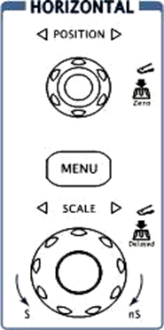

## Tasks

1. Determine the period of the 100Hz sinusoidal waveform by adjusting the waveform on oscilloscope.

**T = 10 ms**

1. Set horizontal sensitivity of the oscilloscope to 2ms/cm by rotating the SCALE knob of the digital oscilloscope.

*How many horizontal divisions will are required to display one full cycle?*

**Number of divisions = 5**

1. Using the oscilloscope measure the number required divisions and insert below. How does the result compare the calculated number of divisions?

**Number of divisions = 5**

***Both the mathematically calculated and the inferences made on the oscilloscope yielded the same value, as the equipment was devoid of any faults.***

1. Change the horizontal sensitivity of the oscilloscope to 5ms/cm by rotating SCALE knob without touching any of the function generators.

*How many horizontal divisions are required to display one full cycle?*

**Number of divisions = 2**

1. Using the oscilloscope measure the number required divisions and insert below. How does the result compare the calculated number of divisions?

**Number of divisions = 2**

***Both the mathematically calculated and the inferences made on the oscilloscope yielded the same value, as the equipment was devoid of any faults.***

1. Change the horizontal sensitivity of the oscilloscope to 1ms/cm by rotating SCALE knob without touching any of the controls of the function generator.

*How many horizontal divisions are required to display one full cycle?*

**Number of divisions = 10**

1. Using the oscilloscope measure the number required divisions and insert below. How does the result compare the calculated number of divisions?

**Number of divisions = 10**

***Both the mathematically calculated and the inferences made on the oscilloscope yielded the same value, as the equipment was devoid of any faults.***

1. What was the effect on the appearance of the sinusoidal waveform as horizontal sensitivity was horizontal sensitivity was changed from 1ms/cm to 5ms/cm?

***As we increase the horizontal sensitivity from 1ms/cm to 5ms/cm, the waveform compresses horizontally; in other words, the number of divisions become lesser.***

1. Did the frequency of the signal on the screen change with each horizontal sensitivity? What conclusion can draw from the results?

***The frequency of the signal does not change with change in horizontal sensitivity. Only the number of divisions alter and but multiplied with the sensitivity scale, it gives frequency which, remains the same.***

1. Determine the frequency of the waveform.

**Frequency = 100 Hz**

### Vertical Sensitivity

Following figure shows the VERTICAL controls, CH1, CH2, MATH, REF, and OFF buttons and vertical POSITION, SCALE knobs. Following the exercise of the buttons, knobs, and the status bar to be familiar with the vertical parameters settings.

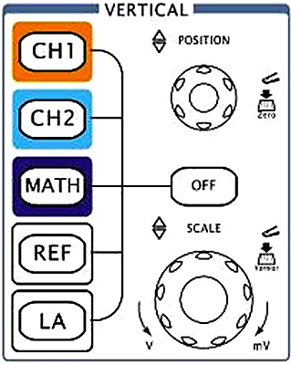

## Tasks

*Set the vertical sensitivity of the scope to 1V/cm by rotating the SCALE knob and adjust the amplitude control of the function generator to establish 4 V peak to peak (p-p) Sinusoidal waveform on the screen.*

1. Do not touch the control of the control of function generator but return the sensitivity of the scope to 1v/cm and change the vertical sensitivity to 2V/cm by rotating the SCALE knob. Using the sensitivity calculate the peak-to-peak value of the sinusoidal waveform on the screen by first counting the number if the vertical division between peak values and multiplying by the sensitivity.

**Peak-to Peak Value = 4 V**

1. Change the vertical sensitivity of the oscilloscope to 0.5V/cm by rotating the SCALE knob and repeat Part (a).

**Peak-to Peak Value = 4 V**

1. Did the peak-to peak value of the sinusoidal waveform change with the change in vertical sensitivity? What conclusion can you draw from the results?

***No, the Peak to Peak value of Voltage remains the same, however, the number of vertical division changes. This is because the input voltage remains the same, and we only alter the scale of a measuring instrument.***

1. What was the effect on the appearance of sinusoidal waveform as the vertical sensitivity was changed from 2 V/cm to 0.5 V/cm?

***As we decrease the vertical sensitivity from 2V/cm to 0.5V/cm, the waveform* *stretches vertically; in other words, the number of divisions become higher.***

1. Did the peak-to peak amplitude of the signal change with each vertical sensitivity? What conclusion can you draw from the results?

***No, the peak amplitude does not alter with a change in the setting of the vertical sensitivity and is solely dependent on the function generator.***

### Exercises

1. Make all the necessary adjustments to clearly display a **5000 Hz 6V p-p sinusoidal** **signal** on the oscilloscope. Establish the zero-volt line at the center of the screen.

**Vertical Sensitivity = 1 V/cm**

**Horizontal sensitivity = 20 us/cm**

**T= 0.2 ms**

1. Calculate the period of the waveform using the number of required horizontal divisions for a full cycle.

**T= 0.2ms**

1. Include your labeled waveform in the lab report.

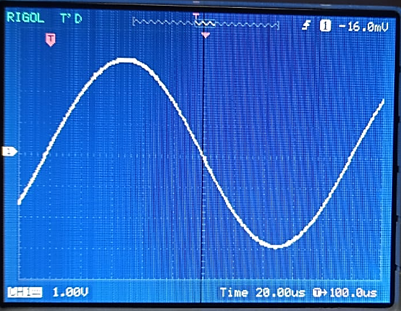

1. Repeat **Part (a)** for a **200-Hz 1.8Vp-p square** waveform

**Vertical Sensitivity = 500 mV/cm**

**Horizontal sensitivity = 500 us/cm**

**T= 5 ms**

1. Include your labeled waveform in the lab report.

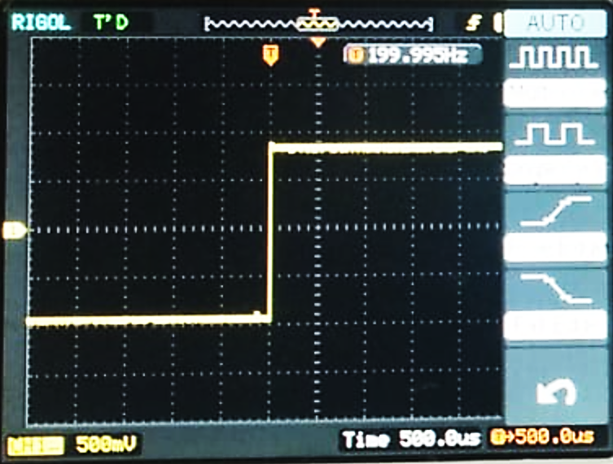

1. Repeat **Part (a)** for a **100-kHz p-p triangular** wave

**Vertical Sensitivity = 1 V/cm**

**Horizontal sensitivity = 1 us/cm**

**T= 1x10-5 s**

1. Include your labeled waveform in the lab report.

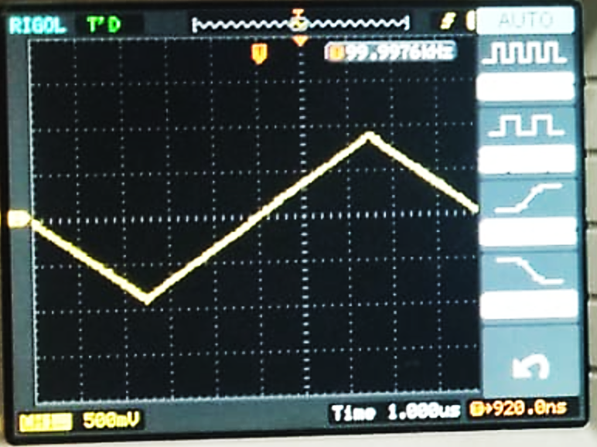

### RMS Value

1. Reestablish the **1 kHz 4Vp-p sinusoidal waveform** on the screen calculate the effective value of the sinusoidal waveform.

**V (RMS) = 1.388 V**

1. Disconnect the function generator from the scope and measure the effective.

(RMS value of the output of the function generator using the digital meter)

**V (RMS) = 1.414 V**

1. Determine the percent difference between the calculate and measured values using the following equation:

$$\% Difference=\frac{V\left(Calc\right)-V\left(Meas\right)}{V\left(Calc\right)}$$

**% Difference = 1.8%**

1. Disconnect the function generator from the DMM and measure the rms value of the output of the function generator using the scope.

**% Difference = 1.8%**

1. What was the difference in DMM and Scope values?

**The Oscilloscope rounds off the measured effective value whereas DMM shows it as is measured, upto 3 decimal places.**

**% Error = (1.4-1.388) / (1.4) = 0.85%**

### Problems

1. Given **V = 5 sin (2000t) +2**, determine the following parameters using scope:

**f** **=** 318.3 Hz

**ω** **=** 2000 rad/s

**T=** 3.14 MS

**Peak value** **=** 7V / -3 V

**Peak-to-Peak value** **=** 10V

**Average Value** **=** 1.97V

**Effective value (RMS)** **=** 4.07 V

**DC level** **=** 2

1. Show the waveform in your report.

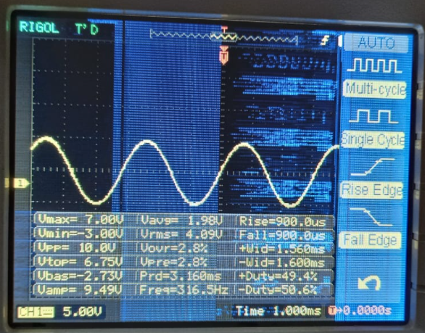

### Exercises

Patch the circuit, shown in the following figure, on a breadboard. Use jumper wires to avoid clutter and ease of measurements. Note that the capacitor used in the experiment will be electrolytic capacitor rather than a non-electrolytic capacitor used in simulation.

Electrolytic capacitors have a positive terminal (anode) and a negative terminal (cathode). Therefore, polarity has to be considered when connecting an electrolytic capacitor.

To differentiate between the anode and cathode look closely at the two pins( terminals) of your capacitor. Both pins are not of equal length. The longer pin is normally the anode whereas the shorter pin is cathode.

However, if it is difficult to differentiate the lengths of two pins, the cathode or negative terminal is usually marked with “-“ sign on the capacitor.

*Leave the voltage source part as we will use a signal generator to generate a sine wave in our exercise 1.*

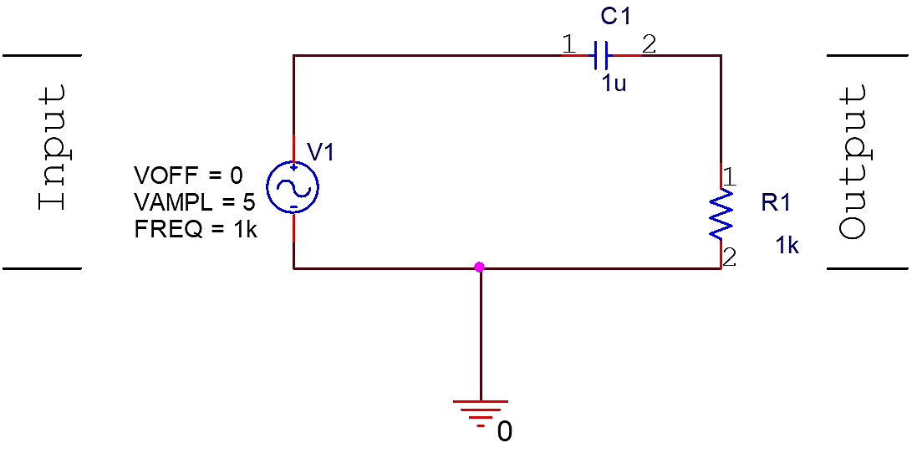

## Exercise 1

**Generating a sinewave of 1kHz**

* Press key [Channel] and select “CHA Frequency” function.
* To set the frequency. Press [**Freq**] and select “frequency”, then press keys [**1**] and the soft key corresponding to [**kHz**] or Adjust the frequency of the channel A: press key [◄] or [►] to move the cursor left or right, and tune the rotary knob left or right to add or subtract the digit on cursor, or to decrease or increase the digits continuously by steps, so as to make coarse or fine adjustment of the frequency.
* To set the amplitude. Press key [**Ampl**] and select “Amplitude”, then press keys [**5**] and the soft key corresponding to [**Vpp**]. You may also set the amplitude by passing the r.m.s value of the amplitude for that press the [**Ampl**] key for second time and you may set your Vrms.
* To select your desired signal type i.e. Sine, Square, Triangle etc.

Press key [**Shift**] followed by the key for your desired signal type.

* Connect the probe of the channel to the circuit you have patched in the given figure.

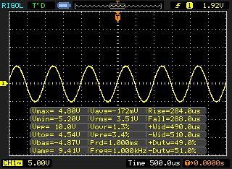

## Exercise 2

**Observing the waveforms using an oscilloscope**

* Now that you have completed the circuit in figure 3. It is time to obtain the results.
* Connect the probes of the oscilloscope to measure the input (Channel 1) and output (Channel 2) voltages as labelled on Figure 3.

(Take care of where you connect you alligator clip).

* Press the [auto] key and sketch the resulting waveforms.

**Q1. What is being controlled by turning the scale knobs?**

**Horizontal:** Time scale is being modified by using horizontal scale knobs.

**Vertical:** Voltage Scale is being controlled by turning vertical knobs.

**Measurements Using Oscilloscope**

* Press [**Auto**] key on your oscilloscope again to return the display to initial settings. Adjust the scales if necessary.
* Press the [**Measure**] key and set the Display setting to on.

**Vrms =** 3.43 V

**Frequency =** 1 kHz

**Time Period =** 1 ms

**Vp2p =** 10 V

**Vmax =** 4.8 V

## Waveform at Input

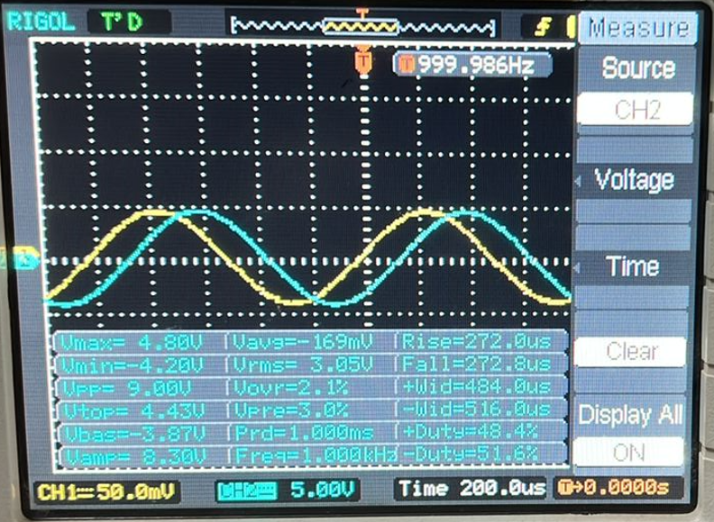

## Waveform at Output

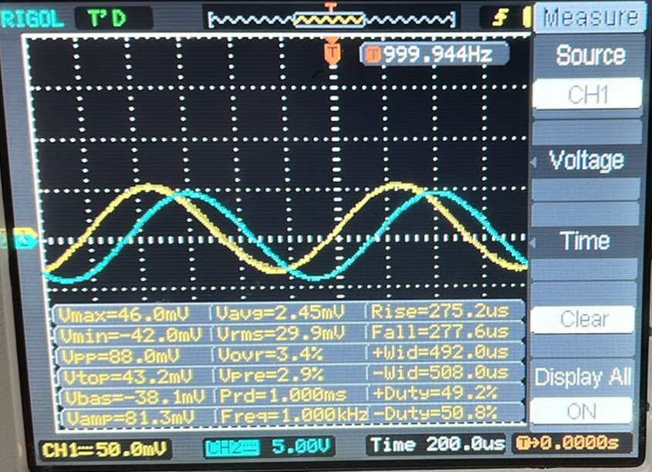

## Note

* Make sure your work is saved and you show the LAB ENGINEER actual simulations that you have performed.
* Lab report is due before the start of next lab

### Conclusion

After performing this lab, we have learnt;

* Increasing our aptitude with digital oscilloscope
* Generate a variety of functions (sine, triangular, square) through means of function generator and utilize it to give input voltage to a simple capacitive circuit
* Implementing voltage divider circuits to utilize both the channels of the digital oscilloscope